ShopNest Store

1.Top Categories by Total Price:
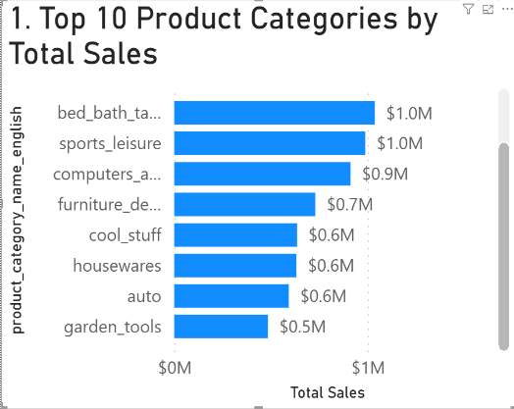

DAX
Total Sales = SUM('Nexusgoods_order_items_dataset'[price])

This visualization highlights the top 10 product categories contributing the highest total sales for ShopNest Store. It helps identify the most profitable categories and understand customer purchasing preferences. Categories such as health & beauty, electronics, and home-related products dominate sales, indicating strong market demand. This insight enables management to focus marketing, inventory, and promotional strategies on high-performing categories.

2. Delayed Orders Analysis:
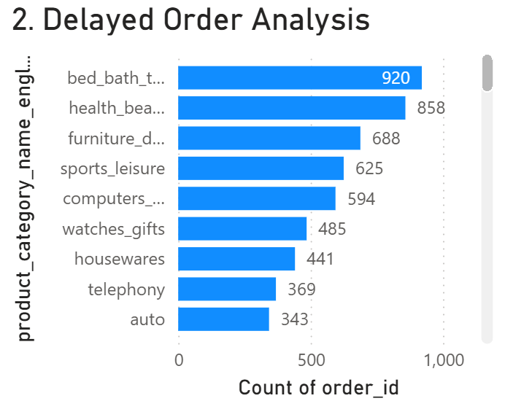
This analysis determines which product categories experience the highest number of delayed deliveries. An order is considered delayed when the actual delivery date exceeds the estimated delivery date. By grouping delayed orders by category, we can identify logistics or supply-chain issues affecting specific product types.

3. Monthly Comparison of Delayed and On-Time Orders:
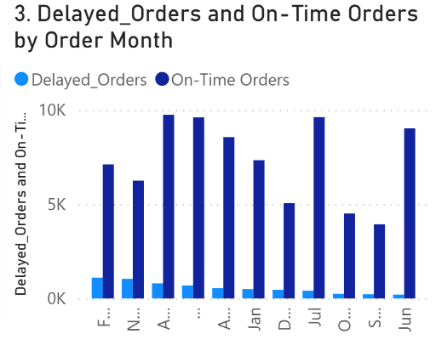
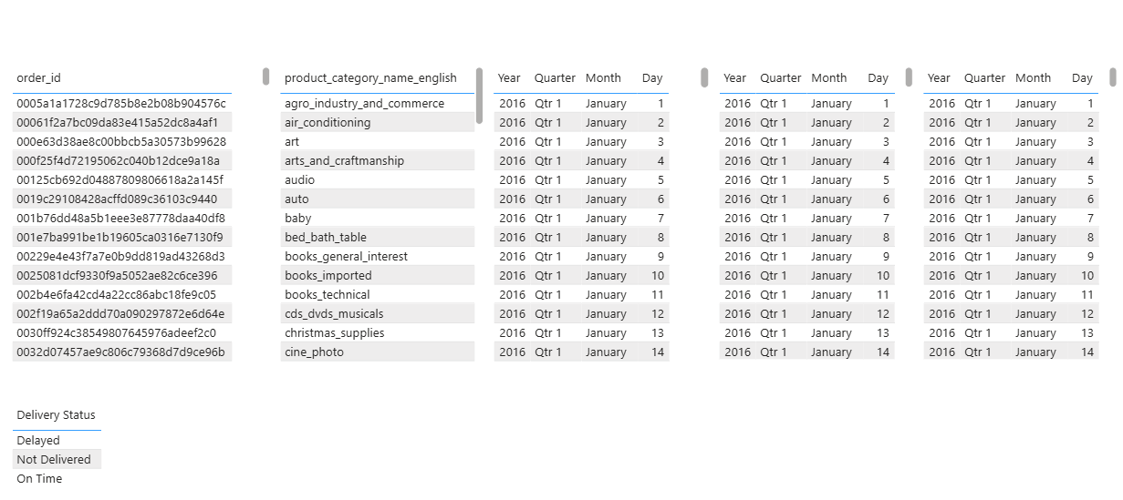
DAX
Delayed_Orders =
COUNTROWS(
FILTER(
Nexusgoods_orders_dataset,
NOT ISBLANK(Nexusgoods_orders_dataset[order_delivered_customer_date]) &&
Nexusgoods_orders_dataset[order_delivered_customer_date]
> Nexusgoods_orders_dataset[order_estimated_delivery_date]
)
)

On-Time Orders =
COUNTROWS(
FILTER(
Nexusgoods_orders_dataset,
NOT ISBLANK(Nexusgoods_orders_dataset[order_delivered_customer_date]) &&
Nexusgoods_orders_dataset[order_delivered_customer_date]
<= Nexusgoods_orders_dataset[order_estimated_delivery_date]
)
)

Order Month = FORMAT ( 'Nexusgoods_orders_dataset'[order_purchase_timestamp], "MMM" )

This analysis compares the number of delayed and on-time orders for each month to evaluate delivery performance over time. A drillthrough feature is used to allow deeper inspection of individual orders, enabling detailed analysis of late and on-time deliveries at the order level.

4. Payment Method Analysis:
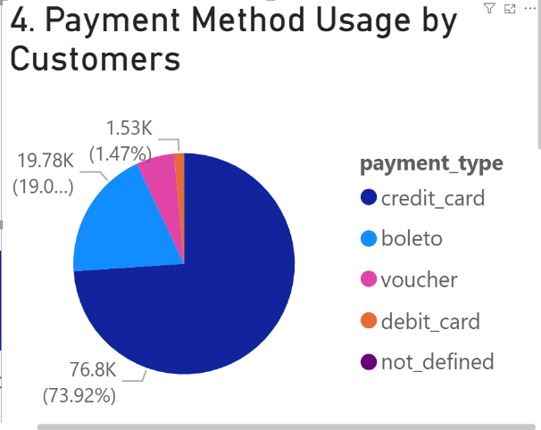
This analysis examines the most frequently used payment methods by customers. By visualizing payment method usage, we gain insights into customer payment preferences, which helps businesses optimize payment options and improve customer convenience.

5. Product Rating Analysis:
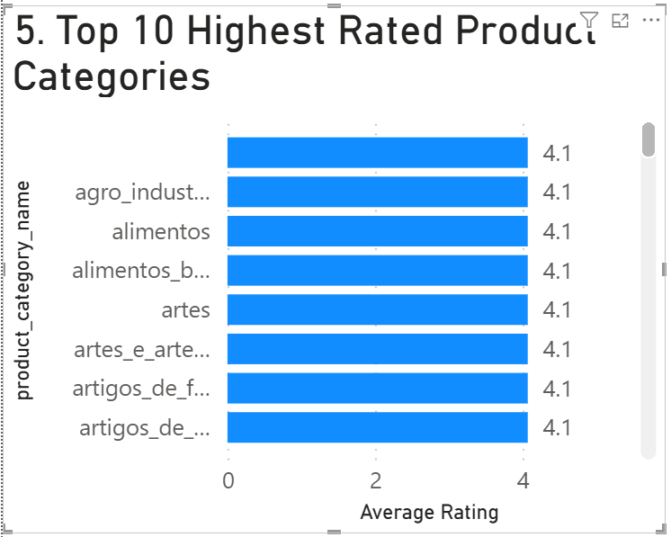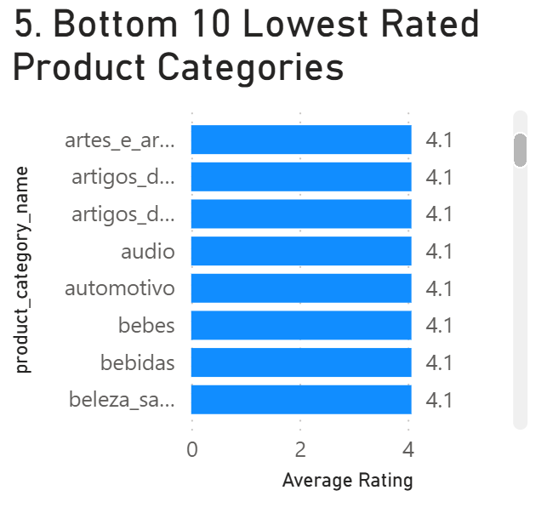
DAX
Average Rating = AVERAGE(Nexusgoods_order_reviews_dataset[review_score])
This analysis identifies the top 10 highest-rated and bottom 10 lowest-rated products (or product categories) based on average customer review scores. It helps in understanding customer satisfaction, highlighting well-performing products and areas that require quality or service improvement.
6. State-wise Sales Analysis:
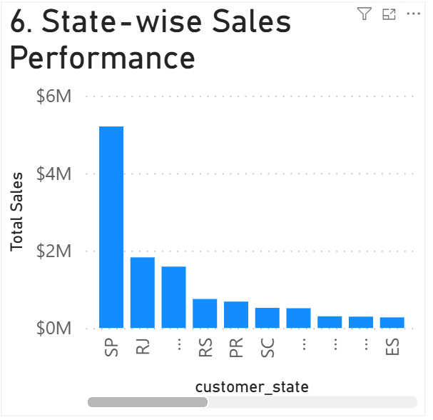
DAX
Total Sales = SUM('Nexusgoods_order_items_dataset'[price])

This analysis shows sales performance across different states, identifying regions with high and low sales volumes. It provides a clear understanding of regional demand patterns, supporting better regional marketing and distribution strategies.

7. Seasonal Sales Patterns:
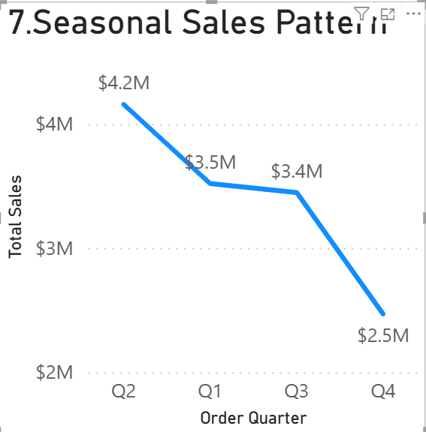
DAX
Total Sales = SUM('Nexusgoods_order_items_dataset'[price])

This analysis investigates quarterly sales trends to identify seasonal patterns in customer purchasing behavior. By analyzing sales across quarters, businesses can understand peak and off-peak seasons, aiding in demand forecasting and promotional planning.

8. Revenue Analysis:
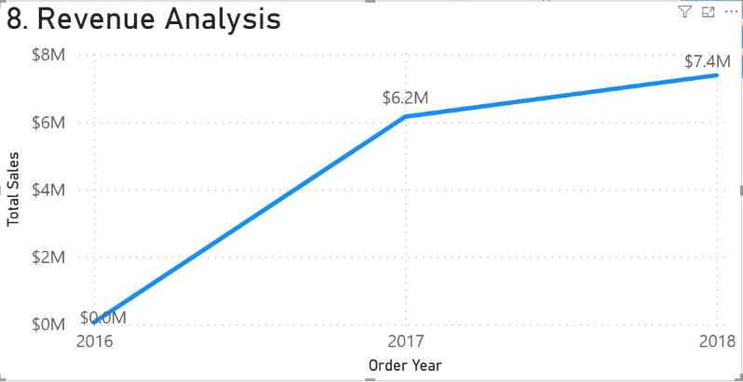
DAX
Total Sales = SUM('Nexusgoods_order_items_dataset'[price])
Order Year = YEAR(Nexusgoods_orders_dataset[order_purchase_timestamp])

This analysis calculates the total revenue generated by ShopNest Store and examines how revenue changes year-by-year. By visualizing revenue trends over time, it helps assess business growth, performance stability, and long-term profitability trends.

